28 April – 10 November 2024
2024 URBAN ART BIENNALE
Burden shed, sintering plant and outdoor area

Staged at the UNESCO World Heritage Site Völklingen Ironworks, the Urban Art Biennale is one of the world’s largest exhibitions of this anarchic form of art. Departing from a conventional white cube aesthetic, the entire site of the Völklingen Ironworks is given over to a fruitful dialogue with an art form that has evolved from street art or graffiti. Established in 2011, the 2024 edition will focus on participatory urban art projects as well as political works in situ.

This year, for the first time, the burner platform on the top floor of the sintering plant will form part of the urban art trail. This space will feature GANZFELD, the largest of the show’s collaborative works, which is being curated and created by Dutch artists Krista Burger and Kenneth Letsoin. Both have been in residence for a number of weeks at the Völklingen Ironworks, where they are inviting anyone and everyone to paint their own picture. These individual pieces are then combined by Letsoin and Burger to create a multi-vocal work that documents varying forms of artistic and social interaction. In this way, a collective installation takes shape over many weeks and months.

At the same time, the Völklingen Ironworks is once again providing a whole variety of auratic locations to stage the encounter of industrial culture with urban art – whether that encounter be between gigantic machinery, against a backdrop of dusty rust-brown walls, or in the area known as Paradise, where nature is progressively reclaiming the former coking plant. Through the involvement of the city of Völklingen and the inclusion of participatory art projects, the 2024 URBAN ART BIENNALE offers more than ever an invitation to dialogue.

The artists
Jef Aérosol (FR) | Allsko (UKR) | Gen Atem (CH) | Ammar Abo Bakr (EG) | Aram Bartholl (D) | | Otto Baum (DE) | Hendrik Beikirch (DE) | Tarek Benaoum (MA) | Miriam Bossard (CH) | Krista Burger (NL) | Stephen Burke (IR) | Codex Urbanus (FR) | Baptiste Debombourg (FR) | Brad Downey (US) | Benjamin Duquenne (F) | e1000 (PL) | Matteo Fluido (IT) | High On Type (NL) | Germain IPIN (FR) | Benjamin Irritant (UK) | Jaune (BE) | Katre (FR) | Kitra (RO) | Lek Sowat (FR) | Kenneth Letsoin (NL) | Levalet (FR) | LOR-K (FR) | M. Chat (FR) | Mardi Noir (FR) | Mentalgassi (DE) | Danilo Milanović (SL) | Moses &Taps (DE) | Mosko (FR) | OX (FR) | Onno Poiesz (NL) | Sébastien Preschoux (FR) | Dan Rawlings (UK) | Daan Rietbergen (NL) | Roadsworth (CA) | Rocco und seine Brüder (DE) | Ralph Roelse (NL) | SpY (ES) | Ian Strange (AU) | The WA (FR) | THWRB3AT (FR) | Mathieu Tremblin (FR) | Vladimir Turner (CZ) | Vhils (PT) | Wayne Horse (DE) | YZ (FR) | Zevs (FR).
With generous support from

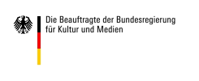
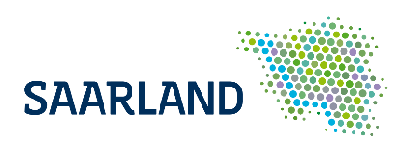

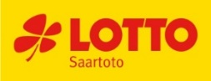
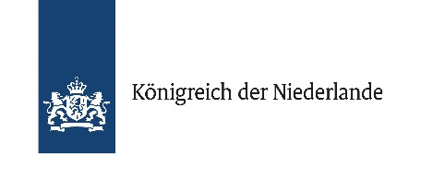

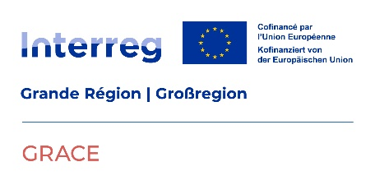

In cooperation with
